TASK 1:
.data
string1 BYTE "Fib Series: ",0
.code
main PROC

mov edx, OFFSET string1
call writestring
call crlf

mov ebx, 0
mov eax, ebx
call writedec
call crlf
mov edx, 1
mov eax, edx
call writedec
call crlf

mov ecx, 10

l1:
mov eax, ebx
add eax, edx
call writedec
call crlf

mov ebx, edx
mov edx, eax

loop l1

exit

OUTPUT:
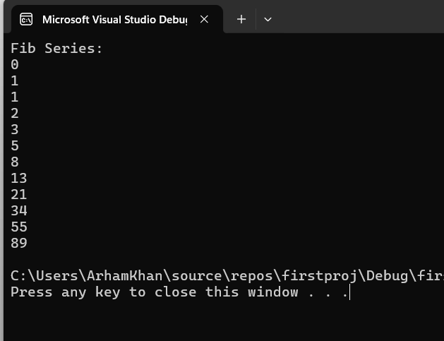

TASK 2:
.code
main PROC
mov eax, 4
mov ebx, 4
mov edx, 4

outer_loop:

mov ecx, ebx

inner_loop: ;4321
call writedec ;321
dec eax ;21
loop inner_loop ;1

call crlf
dec edx
mov eax, edx
cmp ebx, 1
je end1
dec ebx
jmp outer_loop

end1:
exit
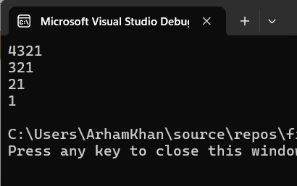
.code
main PROC
mov eax, 1
mov ebx, 4
mov edx, 1

outer_loop:

mov ecx, ebx

inner_loop: ;1111
call writedec ;111
loop inner_loop ;11
;1
call crlf
mov eax, edx
cmp ebx, 1
je end1
dec ebx
jmp outer_loop

end1:
exit
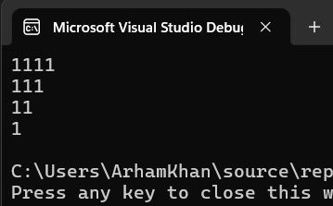
.code
main PROC
mov eax, 1
mov ebx, 4
mov edx, 1

outer_loop:

mov ecx, ebx

inner_loop: ;1234
call writedec ;123
inc eax ;12
loop inner_loop ;1

call crlf
mov eax, edx
cmp ebx, 1
je end1
dec ebx
jmp outer_loop

end1:
exit
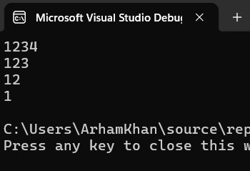
TASK 3:
INCLUDE Irvine32.inc

.data
prompt1 byte "Enter Employee ID of 5 Employees:", 0
prompt2 byte "Enter Birth Year of 5 Employees:", 0
prompt3 byte "Enter Annual Salary of 5 Employees:", 0

prompt4 byte "Entered Employee ID of 5 Employees", 0
prompt5 byte "Entered Birth Year of 5 Employees", 0
prompt6 byte "Entered Annual Salary of 5 Employees", 0
prompt7 byte "Sum of all Employee Salaries:", 0

EmployeeId word 5 DUP (?)
EmployeeBirthYear word 5 DUP (?)
EmployeeAnnualSalary word 5 DUP (?)

.code
main PROC
mov eax, 0
mov edx, OFFSET prompt1
call writestring
call crlf

mov ecx, 5
mov esi, OFFSET EmployeeID
l1:
call readdec
mov [esi], eax
add esi, 2
loop l1

call crlf

mov edx, OFFSET prompt2
call writestring
call crlf

mov ecx, 5
mov esi, OFFSET EmployeeBirthYear
l2:
call readdec
mov [esi], eax
add esi, 2
loop l2

call crlf

mov edx, OFFSET prompt3
call writestring
call crlf

mov ecx, 5
mov esi, OFFSET EmployeeAnnualSalary
l3:
call readdec
mov [esi], eax
add esi, 2
loop l3

call crlf

; ----- printing ------

mov edx, OFFSET prompt4
call writestring
call crlf

mov ecx, 5
mov esi, OFFSET EmployeeID
l4:
movzx eax,word PTR [esi]
call writeint
call crlf
add esi, 2
loop l4

call crlf

mov edx, OFFSET prompt5
call writestring
call crlf

mov ecx, 5
mov esi, OFFSET EmployeeBirthYear
l5:
movzx eax,word PTR [esi]
call writedec
call crlf
add esi, 2
loop l5

call crlf

mov edx, OFFSET prompt6
call writestring
call crlf

mov ecx, 5
mov ebx, 0
mov esi, OFFSET EmployeeAnnualSalary
l6:
movzx eax,word PTR [esi]
add ebx, eax
call writedec
call crlf
add esi, 2
loop l6

mov edx, OFFSET prompt7
call writestring
call crlf
mov eax, ebx
call writeint

exit
main ENDP

END main
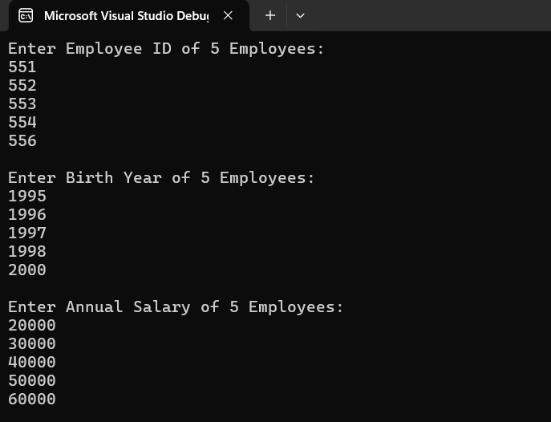
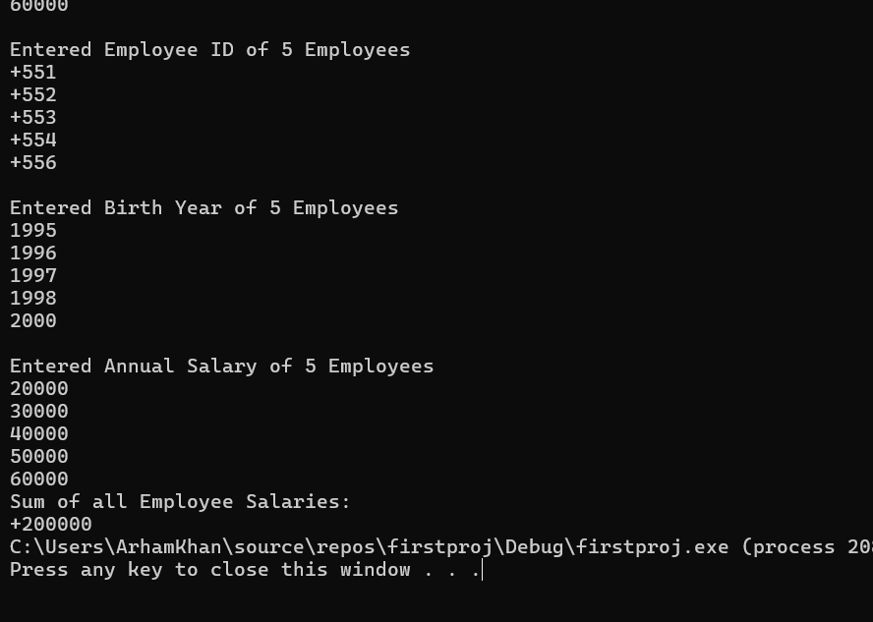

TASK 4:
INCLUDE Irvine32.inc

.data
Source byte "this text will be copied",0
Target byte SIZEOF Source DUP(?)

.code
main PROC
mov eax, 0
mov esi, OFFSET Source
mov edi, OFFSET Target

l1:
mov al, [esi]
mov [edi], al

inc esi
inc edi

cmp al, 0
je CopyDone

loop l1

; displaying it from target array
CopyDone:
mov edx, OFFSET Target
call writestring
call crlf

exit
main ENDP

END main
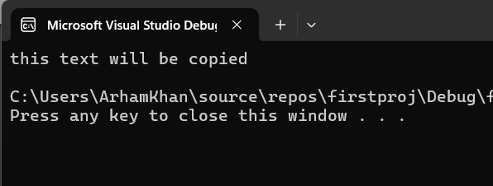
TASK 5:
NOT ABLE to solve this one!

